Unit 5
Organizing
There are so many materials and people in an enterprise. Enterprise uses the manpower and materials for achieving the goals. Materials can be collected, established and coordinated. Manpower must be hired, trained, motivated and put at right place. Managers and workers must be clear about their authority and responsibility. Organization is defined as the determination of relationship between materials as well as human resources. It is most important and basic function of management. It includes division of work, coordination of people and appropriate establishment of materials and resources. Therefore we can say that organization is necessary function of management. Without it a business firm can’t move ahead. In short organization refers to a mechanism which enables man to live together and perform the activities collectively. It is the foundation on which the whole structure of management is built.
Organizing involves
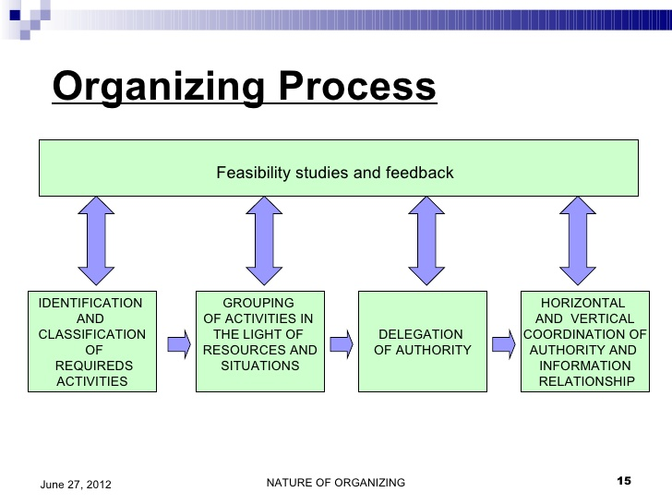

Approaches to organizing
Various approaches have been developed for organizing. The common approaches to organizing are discussed below:

Classical Approach
The classical approach to organizing signifies traditionally accepted norms and systems. This approach focuses on efficiency and recommends that managers continually try to increase organizational efficiency to increase production. This approach includes the ideas of scientific management, administrative management and bureaucratic theory. All these three theories were propounded on almost similar assumption and the practical effort of all the three theories are basically the same.
Scientific management approach: Scientific management theory is developed by F.W. Taylor and later on, several scholars expanded his idea. Notable among them are: Henry L Gantt, Frank and Lillian Gilbreth, Harrington Emerson and William H. Leffingwell. Scientific management is an attitude and philosophy, which discards the traditional method of, hit and miss, rule of thumb, and trial and error of managing work and workers. It is also concerned with development and application of scientific, problem solving approach. Further, the principles of scientific management includes development of a science; scientific selection, training and development of workers, close cooperation between management and workers, equal division of work and responsibility, maximum output in place of restricted output.
Administrative management approach: Henry Fayol, a French industrialist and mining engineer by profession, developed the theory of administrative management. According to him, management is a distinct field of study and which involves many managerial function like forecasting planning, organizing, commanding, coordinating and controlling. He also has divided all industrial activities into six groups consisting of technical, commercial, financial, security, accounting and managerial. Based on his experience he has further developed the fourteen principles of management e.g. division of work, authority and responsibility, discipline, unity of command, unity of direction, subordination of individual interest, remuneration, centralization, scalar chain, order, equity, stability of tenure, initiative. Thus, these principles are universally applicable in all types of organizations.
Bureaucratic approach: Max Weber developed a theory of bureaucracy. It is a form of organization characterized by division of labor, a clearly defined hierarchy, detailed rules and regulations and impersonal relations. He too has offered bureaucratic model for management of any large and complex organization. The features of bureaucracy consist of hierarchy of authority, chain of command, clear cut division of work, system of rules, regulations and procedures, impersonality in interpersonal relations, system of work procedures, selection and promotion based on technical competence and adequate protection of individuals against arbitrary dismissal.

Behavioral Approach
Behavior approach to organizing is concerned with scientific investigation, analysis and understanding of human behavior in organization. It is multidimensional and interdisciplinary in nature. It focuses on human behavior in organization and seeks to promote verifiable propositions for scientific understanding of human behavior in organization.
Behavioral approach to organizing also focuses on psychology, sociology and anthropology. Psychology is the study of human behavior. Sociology is the study of human behavior in groups. Anthropology is the study of physical, biological and cultural influences on human behavior as individuals and members of group. A large number of behavioral scientists have made contributions to the behavioral approach. Notable among them are Abraham Maslow, Duglas McGregor, Fredecric Herzberg, Mary Parker Follet etc.
Abraham Maslow, a human psychologist, has developed a theory of human needs. According to him, people always have needs, and when one need is relatively fulfilled, others emerge in a predictable sequence to take place. Because, human needs tend to follow a basic hierarchical pattern from the most basic needs to the highest level needs. And until the most basic needs are fulfilled, person will not try to meet his higher level needs. He also has classified human needs into five levels as physiological, safety, social, esteem and self actualization needs.
Duglas Mc Gregor has proposed two distinct views of human beings: one negative labeled theory X and another positive labeled theory Y. According to him, theory Y is a set of optimistic assumptions about human nature and theory X is a set of pessimistic assumptions about the worker. As the manager gets the work done from the subordinates, it is necessary for them to understand the behavior of each workers as well as group.
Frederick Herzberg has develop the two factor theory for work motivation consisting of motivating factor and hygiene factor. Hygiene factors are external to the job itself. The presence of these factors does not motivate employees but absence of which cause dissatisfaction. Hygiene factors include company policy and supervision, relationship with supervisor, working conditions, salary, relationship with peers, personal life, relationship with subordinate, job security, status etc. The motivating factor causes high levels of motivation and job satisfaction, whereas absence of which does not cause high dissatisfaction. These factors also include achievement, recognition, advancement, work itself, the possibility of personal growth, responsibility etc. Herzberg came into conclusion that enriched jobs are the key to motivate employees. Therefore, manager needs to identify the behavior of subordinates to inspire them to get the things done. He needs to know workers psychology and treat them accordingly.

Contingency Approach
Contingency approach to organizing is also known as situational or practical approach to management. It was developed by practicing managers, consultants and researchers, who tried to apply the concept of earlier management theories into practice. This approach is based on the premise that there is probably no one best way to solve management problem in all organization.
According to his approach, the best way to lead, plan, organize and conduct managerial activities varies with the situation. A particular method suitable in one organization at a time may not necessarily be suitable to another one organization at other time. Hence, there are no plans, organization structure, and leadership style or control technique that will fit in all situations. Significant differences exist between one situation and other. Every organization is unique and management decision and structure must be unique. The manager must understand and uniqueness and complexity of each situation. There should be a match between situation and the manner of dealing. My previous post was on principles of organizing in management and business. You can check this article.
Therefore, management cannot have readymade universally applicable and patent principles to be applied to all situations as everlasting truth. Hence, management will have to recognize the nature of technology, the variations in human participants, and the wide diversity in environmental relationships. And all managerial actions will depend upon particular prevailing circumstances and situational factors.
- System 4 approach
This approach was developed by Rensis Likert a social scientist his approach focus on interpersonal relation and development of different working group leadership, motivation, communication, decision making and democratic practices with in organization. It recognizes unique value of organizational members and behavioral aspects.
Principles of organizing
1. Principle of unity of objectives: Organizational goals, departmental goals, and individual goals must be clearly defined. All goals and objectives must have uniformity. When there is contradiction among different level of goals desired goals can’t be achieved. Therefore, unity of objectives is necessary
2. Principle of specialization: Sound and effective organization believes on organization. The term specialization is related to work and employees. When an employee takes special type of knowledge and skill in any area, it is known as specialization. Modern business organization needs the specialization, skill and knowledge by this desired sector of economy and thus, efficiency would be established.
3. Principle of coordination: In an organization many equipment, tools are used. Coordination can be obtained by group effort that emphasize on unity of action. Therefore, coordination facilitates in several management concepts
4. Principle of authority: Authority is the kind of right and power through which it guides and directs the actions of others so that the organizational goals can be achieved. It is also related with decision making. It is vested in particular position, not to the person because authority is given by an institution and therefore it is legal. It generally flows from higher level to lowest level of management. There should be unbroken line of authority.
5. Principle of responsibility: Authentic body of an organization is top level management, top level management direct the subordinates. Departmental managers and other personnel take the direction from top level management to perform the task. Authority is necessary to perform the work .only authority is not provided to the people but obligation is also provided. So the obligation to perform the duties and task is known as responsibility. Responsibility can’t be delegated. It can’t be avoided.
6. Principle of delegation: Process of transferring authority and creation of responsibility between superior and subordinates to accomplish a certain task is called delegation of authority. Authority is only delegated, not responsibilities in all levels of management. The authority delegated should be equal to responsibility
7. Principle of efficiency: In enterprise different resources are used. Therese resources must be used in effective manner. When the organization fulfill the objectives with minimum cost, it is effective. Organization must always concentrate on efficiency.
8. Principle of unity of command: subordinates should receive orders from single superior at a time and all subordinates should be accountable to that superior. More superior leads to confusion, delay and so on.
9. Principle of span of control: unlimited subordinates cant be supervised by manager, this principle thus helps to determine numerical limit if subordinates to be supervised by a manager. This improves efficiency.
10. Principle of balance: the functional activities their establishment and other performances should be balanced properly. Authority, centralization, decentralization must be balance equally. This is very challenging job but efficient management must keep it.
11. Principle of communication: Communication is the process of transformation of information from one person to another of different levels. It involves the systematic and continuous process of telling, listening and understanding opinions ideas, feelings, information, views etc, in flow of information. Effective communication is important
12. Principle of personal ability: for sound organization, human resources is important. Employees must be capable. Able employees can perform higher. Mainly training and development programs must be encouraged to develop the skill in the employees
13. Principle of flexibility: organizational structure must be flexible considering the environmental dynamism. Sometimes, dramatically change may occur in the organization and in that condition, organization should be ready to accept the change
14. Principle of simplicity: this principles emphasizes the simplicity of organizational structure, the structure if organization should be simple with minimum number of levels do that its member an understand duties and authorities.
Types of organizational structure
There are three types of organizational structures
- Line organizational structure
- Line and staff organizational structure
- Functional organizational structure
- Matrix structure

Line organization structure
It is the simplest and oldest form of organizational structure. The line of authority flows vertically from top most executive to the lowest subordinate throughout the organization. Where, managers have direct authority over their respective subordinates through the chain of command. Authority flows directly from top to bottom through various managerial positions. It is simple form of organization. Only one form of authority that is line authority exists in this form of organization. Line authority refers to the direct authority of a manager over his subordinates. The authority responsibility relationship is clearly established. All managers in line organization have full authority to decide things and act with respect to their related functions. in line organization department are created for basic activities and departmental heads are responsible for all activities performed in the department.
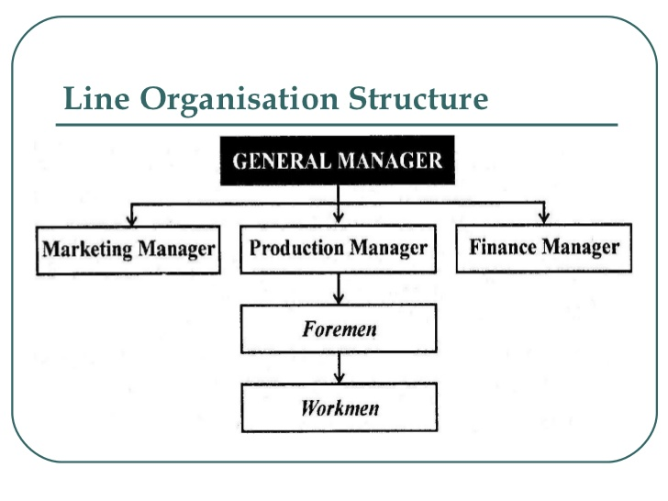
Merits of line organization:
1. It is very simple to establish.
2. It clearly defines the authority, responsibility and accountability of a job
3. It can be easily adapted to the requirement of the organization.
4. Managers have exclusive authority over their unit so they can easily make changes in the functioning of the unit when required
5. There is definite authority at every level so that everyone can take decisions quickly.
6. Every employee knows to whom he/she is responsible and from whom they receive their orders.
7. It confirms scalar principle of organization where one subordinate receives the orders from single superior.
8. All activities relating to single department are managed by one individual.
9. There is clear cut definition of authority and identification of responsibility, relationships and so on.
Demerits of line organization
1. The line executives are generalists and not specialists.
2. The top level managers are overloaded with work.
3. There is concentration of authority at top level only. If top level managers are not capable there may be failure.
4. All managers and supervisors handle their job on their own ways independently with grow the line organization my find it difficult to maintain effective coordination between different departments and units.
5. There is only one way communication i.e. from top to bottom
6. It is not suitable for large organization
7. There is possibility of nepotism and favoritism.
8. There is replacement problem during absenteeism of top authority
9. It can be autocratic.
Line and staff organization structure
In this type of organization structure two type of authority relationship exists. They are staff and line authority. Staff authorities’ means authority to advice, support and serve the line managers. All managerial functions are practiced by line authority with the help of specialized skill of staff authority. It is modification of line organization and is more complex than it. Staff managers and line managers are distinguished on the basis of their role. There is more specialization and division of work. However conflict may arise between line and staff authority.
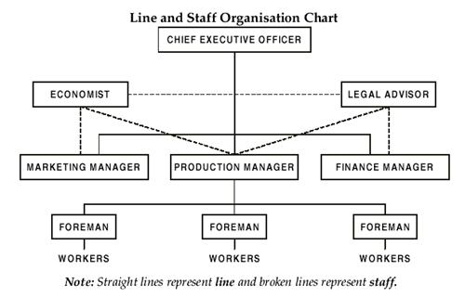
Merits of line and staff organization structure:
1. The line executives are generalists and staff executives are specialists and they work together with coordination
2. The top level managers are not overloaded with work. Staff specialists give relief in critical matters.
3. There is no concentration of authority at top level only. Even if top level managers are not capable there is no failure because staff managers can help to overcome the problematic issues through proper decisions and specialization.
4. All problems are handled with care and are tries to solve with the help of staff specialists.
5. There is two way communications i.e. from top to bottom and bottom to top. There can be feedback and suggestion with orders too.
6. There is better decision taking and improvement in efficiency.
7. It is suitable for large organization
8. There is better utilization of personnel skills and knowledge.
Demerits of line and staff organization
1. It is difficult to establish and is costly too.
2. There is possibility of conflict between the line managers and staff managers. Line managers may ignore staff’s advice and complain that staff doesn’t give right type of advice. Staff managers can complain that their advice is not properly implemented.
3. The allocation of authority and responsibility between the line and staff official I generally not clearly defined.
4. Line managers may be too much dependent upon the staff authority. Staff authority however is not accountable for the result. Sometimes when staff authority do no perform well there may be failure
5. There is wide difference between the approach of line managers and staff managers.
6. There can be reduction of initiative power o line authority.

Functional organization
In functional organization all business activities of an enterprise are divided into number of fractions and each function is entrusted to a specialist, each specialist is known as functional specialist and authority delegated to him is known as functional authority. One of the main features of this organization is that a functional manager can exercise functional authority over his own sub-ordinate but also over all sub ordinates in all other functional departments. The principle of unity of command is not applied in his type of organizational structure. The sub-ordinate may be confused by the multiple command system. The functions are divided into units like marketing, production, research and development, human resource etc.
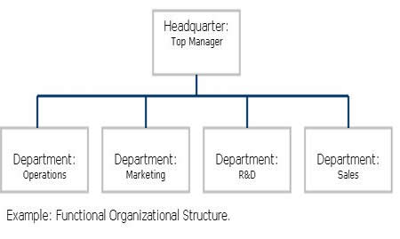

Merits of functional organization structure:
1. It provides benefits of specialist. Every manager is expert in his own field of knowledge. There is advantage of best managerial decisions
2. Here each department is given under supervision of specialist. All decisions about the departments are also taken with the help of specialists.
3. There is no concentration of authority at top level only. Even if top level managers are not capable there is no failure because functional managers can help to overcome the problematic issues through proper decisions and specialization.
4. Functional organization provides preference for growth and expansion of business activity.
5. There is separation of mental and manual work.
6. It is suitable for large organization
Demerits of functional organization
1. Subordinates are always in confusion to obey the orders due to multiple command system.
2. No formal relationship among the departmental specialist.
3. There is lack of mutual understanding and coordination of activities of different department
4. There is delay in decision making.
5. Narrow vision of departmental specialist creates problems in functional organizational.
6. There is weak discipline among the employees.
7. There is lack of fixed responsibility.

For Line organization
- Line managers are generalists.
- The line of authority is vertical as it follows the principle of scalar chain
- There is strict discipline
- It is not based upon planned specialization
- There is unity of command
- It is suitable for small scale operations
- It is quite economical
For Line and staff organization
1. There are experts known as staff to advise and assist the line officials
2. Line authority and staff people with advisory authority
3. Loose discipline
4. It is based upon planned specialization
5. Unity of command observed to a great extent
6. Suitable for medium scale operations
7.Little costlier
For Functional organization
- Functional managers are specialists in their respective areas
- The line of authority is functional or diagonal. The functional manager has authority over the functions wherever it is performed.
- Loose discipline
- Based on high degree of specialization
- Unity of command is not followed as each sub-ordinate gets instructions from his line boss and the functional bosses.
- It is suitable for large scale operations where expert knowledge in certain fields is a must
- Very costly

Matrix structure
It is a type of organizational structure in which people with similar skills are pooled for work assignments, resulting in more than one manager (sometimes referred to as solid line and dotted line reports, in reference to traditional business organization charts).
For example, all engineers may be in one engineering department and report to an engineering manager, but these same engineers may be assigned to different projects and report to a different engineering manager or a project manager while working on that project. Therefore, each engineer may have to work under several managers to get his or her job done.

The matrix for project management
A lot of the early literature on the matrix comes from the field of cross functional project management where matrices are described as strong, medium or weak depending on the level of power of the project manager.
Some organizations fall somewhere between the fully functional and the pure matrix. These organizations are defined in A Guide to the Project Management Body of Knowledge as ’composite’. For example, even a fundamentally functional organization may create a special project team to handle a critical project.
However, today, matrix management is much more common and exists at some level in most large complex organizations, particularly those that have multiple business units and international operations.

Management advantages and disadvantages
Key advantages that organizations seek when introducing a matrix include:
- To break business information silos - to increase cooperation and communication across the traditional silos and unlock resources and talent that are currently inaccessible to the rest of the organization.
- To deliver work across the business more effectively – to serve global customers, manage supply chains that extend outside the organization, and run integrated business regions, functions and processes.
- To be able to respond more flexibly – to reflect the importance of both the global and the local, the business and the function in the structure, and to respond quickly to changes in markets and priorities.
- To develop broader people capabilities – a matrix helps develop individuals with broader perspectives and skills who can deliver value across the business and manage in a more complex and interconnected environment.
Key disadvantages of matrix organizations include:
- Mid-level management having multiple supervisors can be confusing, in that competing agendas and emphases can pull employees in different directions, which can lower productivity.
- Mid-level management can become frustrated with what appears to be a lack of clarity with priorities.
- Mid-level management can become over-burdened with the diffusion of priorities.
- Supervisory management can find it more difficult to achieve results within their area of expertise with subordinate staff being pulled in different directions.

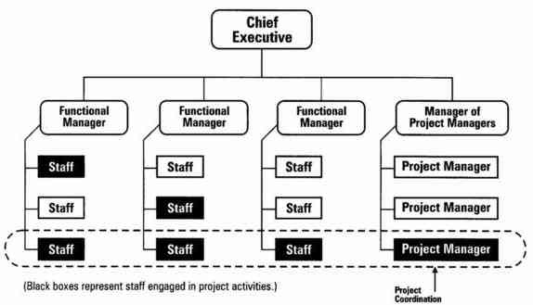
Meaning of authority
Authority is the kind of right and power through which it guides and directs the actions of others so that the organizational goals can be achieved. It is also related with decision making. It is vested in particular position, not to the person because authority is given by an institution and therefore it is legal.
Meaning of responsibility
Authentic body of an organization is top level management, top level management direct the subordinates. Departmental managers and other personnel take the direction from top level management to perform the task. Authority is necessary to perform the work .only authority is not provided to the people but obligation is also provided. So the obligation to perform the duties and task is known as responsibility.
Meaning of accountability
Subordinates receive the authority from top level of the organization and they also receive the command and direction to perform the work. In other words, they are authorized and responsible for a specific function. Sometimes the task may not be performed effectively the subordinates may not be performed effectively. The subordinates must report to boss about the assigned task. S/he must answer his/her performance which is known as accountability.
Meaning of delegation of authority
All activities are not performed by one person. Authority should be provided to the subordinates too. Process of transferring authority and creation of responsibility between superior and subordinates to accomplish a certain task is called delegation of authority. It can take place without decentralization. It can be withdrawn by delegator at any time. It minimizes the burden of managers of unit, departments or plant. Relationship is between superior and immediate subordinates are indicated. It is technique of management used to get the things done through others. It is confined to manager and subordinates. Authority is only delegated, not responsibilities. Very important to management process Control remains in hand of superior who supervise the activities of subordinates. It is an art of management science. When authority is not given to subordinates there is no performance. Delegation is the process of sharing power and work (deliver the power from one to another).
Builds Trust and Understanding
Delegation involves trusting in someone's abilities and relying on them. This helps build a feeling of mutual understanding and trust. It gives managers the opportunity to understand the employees' approach towards work.
Motivates Employees
Entrusting employees with additional responsibilities works as a great motivator at the workplace. An employee who feels trusted; i.e. when he knows that the higher management trusts him and relies on his capabilities, he works with greater efficiency. Delegation of authority makes him feel important and more responsible.
Tests Employee Skills
With authority comes added responsibility, shouldering which, is not easy. It requires one to work with greater focus and efficiency, and to take initiatives, be alert, think creatively, analyze situations, and take decisions. Assessing how well the delegates are functioning can help a manager rate their performance and take decisions about their promotions.
Provides Training
Delegation gives the employees an experience of the actual work, thus providing them with practical training of the job. Delegation of authority involves sharing and transfer of knowledge, thus increasing the delegates' general awareness and know-how of the work. The skills and gained knowledge is tested while working, thus giving the employees an opportunity to prove themselves.
Achieves Work Distribution
This can be considered as a major advantage of delegation, as it reduces the burden of work with the manager, gives more people a chance to share responsibility, and thus leads to a fair distribution of work. Delegating authority for a certain project or task can help a manager concentrate on other more important tasks. Transfer of smaller responsibilities can make it easy for a manager to shoulder greater or more important responsibilities in the organization.
Gives Scope for Innovation
To implement new ideas in the organization, one needs to have certain powers and the right amount of freedom. A rigid framework and lack of authority may restrict an individual from thinking differently. If deserving individuals are given the right authorities, they may be able to bring innovation. Delegation of authority may invite out-of-the-box ideas and positive changes in the organization.
Builds Team Spirit
delegating authority to a group of individuals increases their bonding and mutual understanding. They get a chance to work together towards a common goal, thus building the team spirit.
DISADVANTAGES
Misuse of Power
In delegating authority, there is a risk of the delegate misusing his power for personal gains. He may have access to confidential information, which he may lead to the competitors, or involve himself in other fraudulent activities. This possibility raises a question mark on the employee's integrity, in which case, choosing such an individual as the delegate would be a wrong decision.
Failure to Fulfill the Tasks
The manager's instructions may not be well taken care of by the delegate, or he may not be very particular about following them. This may breed from unwillingness or incapacity of the delegate.
Delay
The delegate may take long to understand the new responsibility. As he has authority, delayed actions on his part may hamper his team's performance. A delay in planning or taking decisions may not be affordable for the organization. Hence, it is not advisable to delegate authority when there is a time crunch.
Impact on Quality of Work
There are chances of quality being affected simply because the employee is new to the work. The experience and knowledge that the manager has, may be lacking in the delegate. He might make mistakes. His way of working may be different. This may impact the overall quality of work. Thus, it is important for a manager to understand that his responsibility does not end after delegation.
Delegation of authority must be planned and executed with care. Only the deserving candidate should be given additional responsibilities. The manager should give clear instructions and provide the delegate with sufficient training. Even after delegating, frequent monitoring may be required in the initial phase.
Managers are reluctant about delegating authority; sometimes due to fear of the delegate outsmarting them, and at times due to a doubt about the delegate's dependability. But if managers look at the bigger picture and if they can choose the right people for delegation of authority, it can work in favor of the organization's growth and success.

Principles of delegation of authority
1. Principle of parity of authority and responsibility- parity of authority and responsibility is one of the important principles of delegation of authority. There is equality in assigned task and power to do the work. Authority to the subordinates is given by the superior on the basis of assigned task. So Authority to the subordinates is given nether more or less than the task otherwise there can be improper utilization of authority and mismanagement of task.
2. Principle of absoluteness of responsibility- according to it, responsibility can’t be delegated. Only authority can be delegated. The person who delegates authority is himself responsible for his seniors.
3. Principle of unity of command- according to it, subordinates must be commanded by one superior, they should take their task from one superior and should be accountable for their responsibility toward the superior level of operation
4. Principle of functional definition of authority and responsibility- as per this principle. Duties and task assigned by the superior and the authority given to fulfill the task should be clearly explained and decided. But this subordinates can know about the limit of one’s right, duties and responsibility.
5. The scalar chain- according to it, authority flows from top to bottom. So that scalar chain is the basis of relationship between the superior and subordinates. It emphasizes the relation between superior and subordinates by which delegation will be easier.
Decentralization
Meaning of decentralization of authority.
Decentralization is delegation of and dispersion of authority from top executive to the low level administrator or it may be geographical dispersion of authority from central to many branches. It is not possible without delegation of authority. It prepares the organizational participants of the organization. It is both philosophy and technique of management. Relationship is between top level, management, departments and units. It involves all managers at all level and relates relationship between departments, sections and units. Withdrawal of authority is not simple in this case. It is optional and situation as per the need of the organization. Control system is also delegated and decentralized to the departmental managers. Superior is relieved from responsibilities too.

Advantages of Decentralization:

1. Reduces the burden on top executives:
Decentralization relieves the top executives of the burden of performing various functions. Centralization of authority puts the whole responsibility on the shoulders of an executive and his immediate group. This reduces the time at the disposal of top executives who should concentrate on other important managerial functions. So, the only way to lessen their burden is to decentralize the decision-making power to the subordinates.
2. Facilitates diversification: Under decentralization, the diversification of products, activities and markets etc., is facilitated. A centralized enterprise with the concentration of authority at the top will find it difficult and complex to diversify its activities and start the additional lines of manufacture or distribution.

3. To provide product and market emphasis: A product loses its market when new products appear in the market on account of innovations or changes in the customers demand. In such cases authority is decentralized to the regional units to render instant service taking into account the price, quality, delivery, novelty, etc.

4. Executive Development:
When the authority is decentralized, executives in the organization will get the opportunity to develop their talents by taking initiative which will also make them ready for managerial positions. The growth of the company greatly depends on the talented executives.

5. It promotes motivation:
To quote Louis A. Allen, “Decentralization stimulates the formation of small cohesive groups. Since local managers are given a large degree of authority and local autonomy, they tend to weld their people into closely knit integrated groups.” This improves the morale of employees as they get involved in decision-making process.

6. Better control and supervision:
Decentralization ensures better control and supervision as the subordinates at the lowest levels will have the authority to make independent decisions. As a result they have thorough knowledge of every assignment under their control and are in a position to make amendments and take corrective action.

7. Quick Decision-Making:
Decentralization brings decision making process closer to the scene of action. This leads to quicker decision-making of lower level since decisions do not have to be referred up through the hierarchy.

Disadvantages of Decentralization:
Decentralization can be extremely beneficial. But it can be dangerous unless it is carefully constructed and constantly monitored for the good of the company as a whole.
Some disadvantages of decentralization are:

1. Uniform policies not followed:
Under decentralization, it is not possible* to follow uniform policies and standardized procedures. Each manager will work and frame policies according to his talent.

2. Problem of Co-Ordination:
Decentralization of authority creates problems of co-ordination as authority lies dispersed widely throughout the organization.

3. More Financial Burden:
Decentralization requires the employment of trained personnel to accept authority, it involves more financial burden and a small enterprise cannot afford to appoint experts in various fields.

4. Require Qualified Personnel:
Decentralization becomes useless when there are no qualified and competent personnel.

5. Conflict:
Decentralization puts more pressure on divisional heads to realize profits at any cost. Often in meeting their new profit plans, bring conflicts among managers.
Difference between delegation and decentralization of authority
Bases | Delegation of authority | Decentralization of authority
Nature | Process of transferring authority and creation of responsibility between superior and subordinates is called delegation. It can take place without decentralization | Decentralization is delegation of and dispersion of authority.  It is not possible without delegation of authority
Purpose | It minimizes the burden of managers of unit, departments or plant | It prepares the organizational participants of the organization
Relationship | Relationship is between superior and immediate subordinates are indicated | Relationship is between top level, management,  departments and units
Techniques | It is technique of management used to get the things done through others | It is both philosophy and technique of management
Parties | It is confined to manager and subordinates | It involves all managers at all level and relates relationship  between departments, sections and units.
Responsibilities | Authority is only delegated, not responsibilities | Superior is relieved from responsibilities too
Necessity | Very important to management process | It is optional and situational as per the need
Control | Control remains in hand of superior who supervise the activities of subordinates | Control is delegated and decentralized to the  departmental managers
Withdrawal of authority | It can be withdrawn by delegator at any time | Withdrawal of authority is not simple.

Meaning of coordination
It is defined as a harmonization of all resources and activities that facilitates in work. It is the essence of management for the achievement for the achievement of harmony of individual effort towards the accomplishment of group goals. It is a process by which the manager achieves harmonious group effort and unity of command of action for the attainment of a common purpose. Without coordination, other function of management can; t integrated.
“Coordination deals with the task of blending efforts in order to ensure successful attainment of an objective.”
Importance of coordination
1. Unity of action: – an enterprise has diverse resources; technique, activities etc and they all must be coordinates to bring unity through unity in action.
2. Increase in efficiency and economy: – coordination brings efficiency because it is an effort of all organizational members. It also helps to maintain good relation among all levels of management.
3. Development of personnel: – coordination helps to obtain information about job, qualities of a job holder which helps to analyze about the potentialities of the job holder and improve coordination system
4. Differential perception: – different people have different perception. When all people are coordinated effectively their effort and power are concentrated to achieve organizational goals.
5. Survival of the organization: – coordination helps to harmonize the work resources and physical facilities. When there activities are not harmonized the organization can’t achieve the goal and it can’t survive in the society
6. Accomplishment of objectives: – when the employees, their task and available resources are coordinated, their production will be increased and it helps to accomplish the objectives of the organization
7. Basis of managerial function: – all managerial functions such as planning, organizing, directing, controlling etc can’t be conducted effectively without communication.
8. Specialization: – in the absence of coordination in the organization the activities can’t be moved in specialized areas. Therefore, it helps in specialization
Means/ techniques of coordination
1. Well defined goals: – the first means or technique of coordination is well defined goals. The goals of the organization should be clear and well defined. Each individual in the organization should understand the overall goals. When the goals are not well defined the coordination may not effective.
2. Sound organization structure: – coordination is the essence of management. It is not possible without sound organization structure. The authority and responsibility for each and every positions and employees should be clearly defined.
3. Effective communication: – coordination helps in creating proper understanding among persons. Without effective communication, coordination may be effective. The ideas, opinions should be interchanged freely. It is only through effective communication that even individual understand his/her limitations, positions and responsibility in the organization. Effective communication helps in coordination. Therefore, it is also an important means of coordination.
4. Proper leadership: – proper leadership leads the subordinates effectively and efficiently. A good managerial leader uses the motivational tools to coordinate the employees with effective communication system. In short, coordination is made possible through proper leadership.
5. Proper supervision: – supervisors coordinate the subordinates and their activities. Top level management cannot coordinate all employees. In short, proper supervision helps in effective coordination.
6. Better plans and policies: – coordination is made according to plans and policies of the organization and departments. When the plans and policies are not better coordination is not effective in the organization.
7. Cooperation: – without cooperation, coordination may not succeed because coordination is related to employees and their activities. When they are not cooperative, coordination may not be made. So, cooperation is essential in the organization.
8. Meeting and conference: – coordination may be possible when all employees their all activities and departmental goals are involved in organizational planning and policies. Their all problems and matters may be involved. When there is environment of constructive discussion and debate with meeting and conference
9. Group decision: – the group decision is a decision in which all members of the organization are participated to make decisions. The ideas and feelings are mixed into the decision and coordination may succeed

Unit 10
Controlling

Meaning of controlling
Controlling is the basic managerial function. It is the process of ensuring the actual activities confined to planned activity. It is an essential function for all levels of management. It ensures the right things are done in the right manner at right time. Each and every organization set the goals. All activities are directed towards the goals. Controlling is defined as a measurement of Actual performance and expected performance and taking corrective action. Its purpose is to make sure that actual performance is consistent with plans. In fact control helps managers to monitor the effectiveness of their planning, their organizing and their directing activities.
Process of controlling
1. Establishing or setting standards– the first step of controlling is to set standard against which results can be measured. For setting standard, targeted results must be identified and it should be quantitative as far as possible. Quantitative term can make controlling effective. Standards are expressed in general term as
a. Cost should be reduced
b. Orders should be executed
c. Overhead must be reduced
d. All orders must be executed in 2 days or so on.
Standards can be expressed in qualitative as well as qualitative terms. The quantitative are physical standard, cost and revenue standards, capital standards etc. the qualitative standards are related to employees morale, motivation, relations between superior and subordinates and public etc. quantitative standard should be flexible.
2. Measuring actual performance– in this step, actual performance of employees, group or units is measure. A manager should examine actual performance on the basis of given standard which id definite set of work assigned to definite employees different techniques can be used to measure the actual performance. In convenience of manager, he develops better information system to measure the actual performance. Actual performance measurement system should be a regular and constant basis so that it can provide reliable and regular feedback to the management.
3. Comparing actual performance with standard– after measuring actual performance, those results should be compared with standard set in the first step to know if the exp results are achieved or not . For that, good sys of comparison between performance and standard should be maintained. These comparison should reveal it the actual performance is equal, lower or higher than that of predetermined standards. If lower standards are achieved the manager should find out the deviation and take corrective action.
4. Taking corrective actions– after comparing actual performance with the standard, if any deviation is detected, and then corrective actions should be taken and initiated. If performance does not meet the standard, it is duty of manager to take corrective action and further help the organization to overcome any difficulty. The corrective action may be related to
a. Revision of standard if they seem to be unattainable
b. Revision of strategies, policies and procedures
c. Additional employees training
d. Greater motivation
e. Change in the existing technique of direction
f. Product design improvement
Importance of controlling
1. Execution of plans– control helps in ensuring the performance of plans through regular examination and evaluation of performance of work that results the performance of activities for accomplishment of goals.
2. Helps in supervision– control helps in reducing deviation between standard performance and actual performance through effective control system established by the supervisor
3. Effective delegation and decentralization of authority – Controlling is that mechanism which monitor about authority issued that can help to delegate and decentralize the authority
4. Reduction of cost– when control is effective employees will have better performance, proper utilization of resources and prevention of leakage and wastage which helps in reduction of cost
5. Psychological pressure controlling affects the psychological pressure of employees. When the employees know that their performance and activities done will be evaluated and just than they naturally work hard and their performance will be increased.
6. Optimum utilization of resources– controlling plays a vital role for proper utilization of human, physical, and financial resources to ensure correct work performance with respect to cost, quality and time or not.
7. Helps in fulfillment of goals– control provide standard for approval of actual performance it helps to accomplish the plan and achieve goals.
8. Helps in coordination– an organization grows in size and diversity. They become complex and also have to develop various department and units. Therefore, controlling help to establish the coordination in different department and units
Essentials of effective control
1. Suitability– the control system should be appropriate to the nature and needs of various activities to serve the specific area or department of the organization
2. Timely and forward looking– control system in the management of the organization should be used to evaluate the deviations timely and take corrective measures in time.
3. Simplicity– effective control system should be very simple and easy to understand by the concerned manager and subordinates.
4. Economy– the controlling system should be very economic and less costly. The benefits should be more than that of actual expenditure related to the common goal
5. Objectives– the control system should be objective in order to specify the expected result in definite terms in terms of personal likes and dislikes of manager, subordinates and other information users etc.
6. Flexibility– every organization operates business in a dynamic environment. Controlling system should ne flexible so that it could be adjusted in every environment
7. Focus on strategic plans– controlling system should focus on critical areas where deviations from standards are most likely to occur and they cause loss and damage. So controlling system should concentrate on those areas where corrective action can be applied effectively
8. Coordinates with organizational workflow– the information to be used for the control must be coordinated with the organizational work flow for two main reason:
a. Each step in the workflow may affect the entire authority
b. Control information must reach every one who needs it.
9. Prescriptive and operational– control system should be prescriptive and operational. And if it does not prescribe remedies and help for smooth operation, it is not useful.
Types of control system

Pre control/ Feedforward Control
Feedforward control focuses on the regulation of inputs (human, material, and financial resources that flow into the organization) to ensure that they meet the standards necessary for the transformation process.
Feedforward controls are desirable because they allow management to prevent problems rather than having to cure them later. Unfortunately, these control require timely and accurate information that is often difficult to develop. Feedforward control also is sometimes called preliminary control, precontrol, preventive control, or steering control.
However, some authors use term "steering control" as separate types of control. This types of controls are designed to detect deviation some standard or goal to allow correction to be made before a particular sequence of actions is completed.
- Concurrent Control
Concurrent control takes place while an activity is in progress. It involves the regulation of ongoing activities that are part of transformation process to ensure that they conform to organizational standards. Concurrent control is designed to ensure that employee work activities produce the correct results.
Since concurrent control involves regulating ongoing tasks, it requires a through understanding of the specific tasks involved and their relationship to the desired and product.
Concurrent control sometimes is called screening or yes-no control, because it often involves checkpoints at which determinations are made about whether to continue progress, take corrective action, or stop work altogether on products or services.
- Feedback Control
This type of control focuses on the outputs of the organization after transformation is complete. Sometimes called postaction or output control, fulfils a number of important functions. For one thing, it often is used when feedforward and concurrent controls are not feasible or are to costly.
Sometimes, feedback is the only viable type of control available. Moreover, feedback has two advantages over feedforward and concurrent control. First, feedback provides managers with meaningful information on how effective its planning effort was. If feedback indicates little variance between standard and actual performance, this is evidence that planning was generally on target.
If the deviation is great, a manager can use this information when formulating new plans to make them more effective. Second, feedback control can enhance employees motivation.
The major drawback of this type of control is that, the time the manager has the information and if there is significant problem the damage is already done. But for many activities, feedback control fulfils a number important functions.

Unit 7
Leadership

Meaning of leadership
Leadership is defined as personal quality of an individual that influence the behavior of followers. It is an important function of management. Leadership is an act of influencing people so that the followers follow the path of leader. The successful leader must lead to stimulate and inspire the followers to achieve organizational goals. In an organization the manager is a leader and other subordinates are followers. A manager cannot manage effectively unless he can lead his subordinates effectively. Hence a leader may or may not be a manager but a successful manager must be a leader.
Leadership is defined as influence, that is, the art or process of influencing people so that they will strive willingly and enthusiastically towards the achievement of group work.
Function of managerial leader
- Leader is true representative of the organization who represents the organization to those working for it as well as to the outside world. A leader functions as a chain between management and staff. S/he represents management before the workers and work before the management
- A leader must establish organizational goals. It is the primary function of the leader. S/he also should participate with superior to get it done
- When the skill and knowledge of the subordinates are not used properly a managerial leader must provide the guideline and effective path as motivational factor to them
- A leader must act like a captain to the team, must win the confidence of most of the colleagues and encourage team work.
- The leader must design proper system of communication and communicate authority and responsibility to its subordinates so that they can know about their work
- A managerial leader must understand problems and feelings of the subordinates and try to solve them tactfully
- A leader must maintain good relationship with subordinates and other people
- A good managerial leader must facilitate change in the organization whenever and wherever necessary.
- A leader has the responsibility to control, supervise and see different departments to achieve organizational goals
- A leader should be able to evaluate the performance of subordinates. There must be provision of both reward and punishment.

Leadership style

1. Autocratic leadership style: – when the authority and decision making power are concentrated to the leader is known as autocratic leadership style. There is no participation by subordinates. The leader takes full authority and assumes full responsibility. Planning, policies and other working procedures are predetermined by the leader alone. The convey the information about what to do and how to do. He never takes any advice and suggestions of other people. They structure the entire work situation in their own way and expect the workers to follow their orders and tolerate no deviation from their order. They are just like tyrant rulers. The leader who believes and exercised the autocratic leadership style is known as autocratic leader.
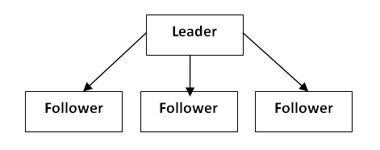

Features:-
- He/she makes his own decisions and he/she doesn’t not take any advice of others because he/she thinks he/she is only superior.
- His/her position gives him/her personal authority and right to lead the members in any way he/she desires.
- Reward and punishment is exercised by him/her very strictly. Autocratic leadership style believes on negative motivational tools.
- An autocrat leader does not give full information to the members. There is only one way communication in order to maintain the position.
- An autocratic leader describes each job in detail and imposes rigid work standard on his employees. It means the subordinates are compelled to certain work assigned for him.
Advantages:-
- It is useful in emergency or in war,
- When the workers are undisciplined and uneducated it gives the best results.
- When the laborers are not organized, it is more effective.
- There is no need of trained labor. It may be used for untrained workers.
- It is a prompt process of decision making as the single person decides for the whole group.
Disadvantages:-
- Subordinates are not involved in the process of decision making in autocratic leadership style
- It doesn’t emphasize on correct evaluation of employee’s performance
- The moral of employees is so low.
- There is no chance of management development.
- There is no chance of two-way communication.
- Creative ideas and thinking cannot be used in autocratic leadership style.
- The employees perform the work with negative motivation.

2. Democratic leadership style

When the authority and decision making power are decentralized to the subordinates is known as democratic leadership style. There is participation by subordinates. The leader delegates authority and provides responsibility even to the followers. Planning, policies and other working procedures are determined by the leader along with suggestions of the followers. He conveys the information about what to do and how to do just as a consultant. He takes advice and suggestions of other people. They structure the entire work situation in democratic way. They are just like democratic rulers. The leader who believes and exercised the democratic leadership style is known as democratic leader.
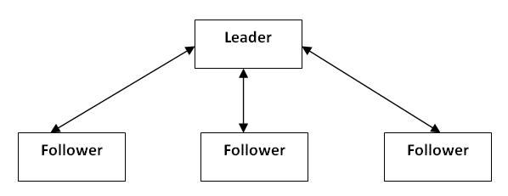

Features:-
- A democratic leader delegates the responsibility as per the capability of the employee
- There is participation of all subordinates in decision making
- Human values are also given preference. The leader gives concerns for the followers
- Democratic leader imposes flexible work standard, designs goals with freedom for the performance of work.
- A democratic leader emphasizes in results than on action

- Advantages: –
- Good cooperation among employees is made in democratic leadership style.
- Employees are highly satisfied and their morale is increased
- Human efforts are highly recognized
- It helps in increasing in productivity.
- Policies, planning and other working procedures become better because different kinds of logic ideas and creativity are mixed.
- Subordinates have grown considerable freedom of action that helps to increase the personal growth and gets opportunity to utilize their capabilities
Disadvantages: –
- It takes long time in decision making.
- It is not suitable for untrained subordinates’
- A leader may to be responsible in his style
- It is not suitable when the followers are undisciplined and untrained

3. Free rein leadership style
when all the authority and responsibility are delegated to the subordinates is known as Free rein leadership style. The leader who believes on this style is known as free rein leader. The free rein leader doesn’t use the power and leaves the power to the subordinates. He/she doesn’t provide any contribution to make planning and policies. This type of leadership style is very useful when group members are intelligent and fully aware of their roles and responsibilities.
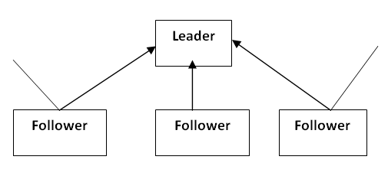
Features
- Subordinates have complete freedom in decision making
- The subordinates are self-directed, self-motivated and self-controlled
- The role of free rein leader is to provide facilities, materials and information to the employees.
- The leader doesn’t interfere in making planning and policies

Advantages: –
- The employees are satisfied in their job because they are free in decision making
- The morale of employees is developed.
- The employees are highly developed because there is maximum possibility for the development of workers.
- The creativity and potentiality of subordinate are fully utilized.

Disadvantages:-
- Leader contribution is ignored.
- Sometime the subordinates are not self-directed.
- Subordinates should not get the guidelines of the leader.

Managerial grid style of leadership

Introduction
Anticipating situational leadership, American Robert Blake and Jane Mouton arrived at the conclusion in 1964 that the behaviour of a leader stems from two criteria: people orientation (concern for people) and task orientation (concern for production) In the so-called managerial grid, they combined these two criteria as a result of which a grid with 81 leadership styles was created.

Under the microscope
On the vertical axis of the managerial grid, the concern for people is depicted from low to high. On the horizontal axis of the managerial grid, concern for production is represented from low to high. The more a leader aims at result orientation, the more attention he pays to working methods, work preparation, rules and regulations and the results of the employees. The more emphasis a leader puts on his employees, the more he aims at motivation, guidance and instruction of employees. He will stimulate group connection and fully aim at motivational labour conditions and learning processes of his employees.

Basic styles of the managerial grid
In the Managerial Grid Robert Blake and Jane Mouton score the criteria ‘concern for people‘ and ‘concern for production‘ from 1 (low) to 9 (high). The Managerial Grid creates 81 combinations that result in 81 different leadership styles. All these styles are subdivided into four quadrants and five basic leadership styles that are given a name and marks:
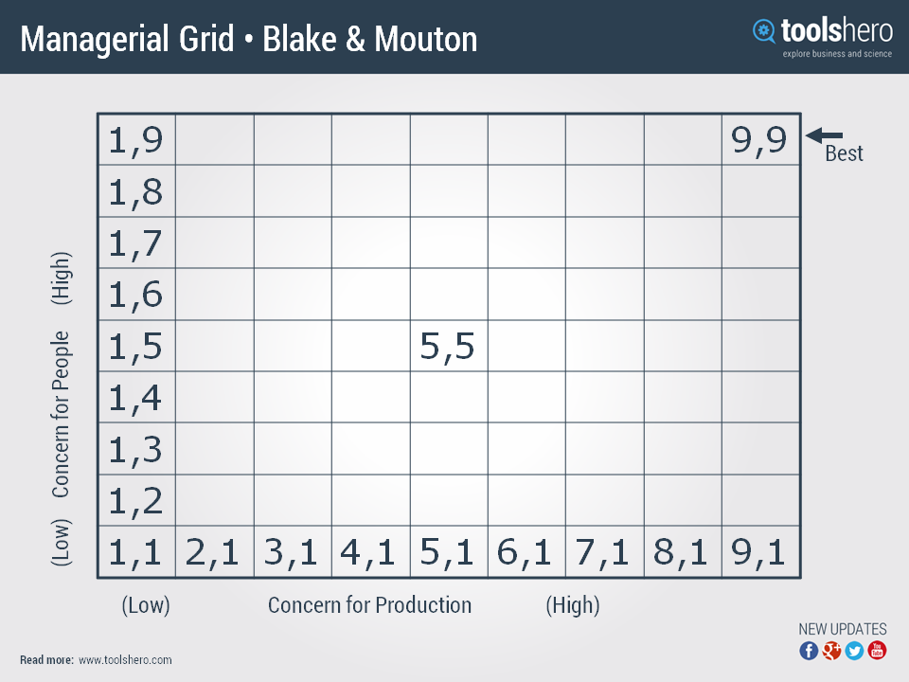

1.1 Impoverished Management (avoiding)
In this leadership style the leader shows little or no concern for production and little or no concern for the employee. When the leader does not wish to engage with his employees and lets them muddle on, this is a bad leadership style. Robert Blake and Jane Mouton indicate however that this style can be a conscious choice. By giving employees the freedom to solve a specific problem, this will affect the production for a short while. But eventually, this will lead to independence and an improved production. When this leadership style is used overly much or continuously, Robert Blake and Jane Mouton recommend to take on a different leadership style.

1.9 Country club (ironing out)
Many new leaders orient themselves towards this style with a high concern for people but a low concern for production. In this style of leadership, leaders just want to be ‘liked‘ by their employees and they do not want to come across as too authoritarian. The leader wants to understand his employees continuously and wishes to maintain a good relationship with them whatever the cost with the risk that the employees might cut corners and do not pursue the objectives enough. This style may also be the leader’s conscious choice. The moment an employee has to deal with personal problems the manager’s care and support will be experienced as positive. It will temporarily affect the production but the backlog will be caught up at a later time.

9.1 Task Management (pushing through)
The leader is completely focused on task-orientation. As the production is the leader’s focal point of attention, he forgets and neglects the well being of the employees. This leader is authoritative and he exerts disciplinary pressure. The leader requires the utmost of the employees and imposes sanctions when they fail to meet the requirements. Robert Blake and Jane Mouton indicate that there are situations in which this style of leadership is necessary. For instance when unpopular measures are taken like cutbacks or reorganization. The leader should not be afraid to show his human side from time to time, however.

5.5 Middle of the road (compromising)
In this leadership style the ‘happy medium‘ course is adopted. The leader maintains a balance between the needs of the people and the production and the leader scores an average mark on both criteria. According to Robert Blake and Jane Mouton this is not always an ideal leadership style but because of pressure of time such as meeting deadlines, it is a good way to encourage the employees.

9.9 Team Management (team-oriented)
The leader that is oriented towards this style should not change this. His employees form a close-knit team and work together on the execution of objectives. The leader has got a lot respect for his employees and enthuses and motivates them. This is why they are able to bring out the best in themselves, Mutual involvement among the employees is high and they are very loyal to their employer. Such an optimal cooperation is often linked to short-term projects that are carried out by (highly) experienced employees. By paying a lot of attention to the needs of the employees and the production this leader works very efficiently.

Green zone within the Managerial Grid
As the style of the leader is also determined by the situation, Robert Blake and Jane Mouton indicated that the best starting position within the Managerial Grid can be found between 5.5 (middle of the road) and 9.9 (team). They called the space in between the ‘green zone‘. The leadership style is only effective when other styles are applied per situation. They recommend that the basic leadership style must be taken from the green zone.
It is advisable to eliminate all emotions towards the employees and to fully focus on the production. But when emotions are running high among employees, a leader would do well to focus his attention on the people’s needs, even if this is at the expense of the production. It is therefore more efficient to apply various leadership styles.
Four system style of leadership
Rensis Likert identified four main styles of leadership, in particular around decision-making and the degree to which people are involved in the decision.

Exploitive authoritative
In this style, the leader has a low concern for people and uses such methods as threats and other fear-based methods to achieve conformance. Communication is almost entirely downwards and the psychologically distant concerns of people are ignored.

Benevolent authoritative
When the leader adds concern for people to an authoritative position, a 'benevolent dictatorship' is formed. The leader now uses rewards to encourage appropriate performance and listens more to concerns lower down the organization, although what they hear is often rose-tinted, being limited to what their subordinates think that the boss wants to hear. Although there may be some delegation of decisions, almost all major decisions are still made centrally.

Consultative
The upward flow of information here is still cautious and rose-tinted to some degree, although the leader is making genuine efforts to listen carefully to ideas. Nevertheless, major decisions are still largely centrally made.

Participative
At this level, the leader makes maximum use of participative methods, engaging people lower down the organization in decision-making. People across the organization are psychologically closer together and work well together at all levels.
Situational leadership style
The situational leadership theory (or situational leadership model) is a leadership theory developed by Paul Hersey, professor and author of the book The Situational Leader,^{[1]} and Ken Blanchard, leadership trainer and author of The One Minute Manager, while working on the first edition of Management of Organizational Behavior.^{[2]} The theory was first introduced as "Life Cycle Theory of Leadership".^{[3]} During the mid-1970s, "Life Cycle Theory of Leadership" was renamed "Situational Leadership theory".^{[4]}
In the late 1970s/early 1980s, the authors both developed their own models using the situational leadership theory; Hersey - Situational Leadership Model and Blanchard et al. Situational Leadership II Model.^{[5]}
The fundamental underpinning of the situational leadership theory is that there is no single "best" style of leadership. Effective leadership is task-relevant, and the most successful leaders are those who adapt their leadership style to the maturity ("the capacity to set high but attainable goals, willingness and ability to take responsibility for the task, and relevant education and/or experience of an individual or a group for the task") of the individual or group they are attempting to lead or influence. Effective leadership varies, not only with the person or group that is being influenced, but it also depends on the task, job or function that needs to be accomplished.^{[4]}
The Hersey-Blanchard Situational Leadership Model rests on two fundamental concepts; leadership style and the individual or group's maturity level.

Unit 6
Managing Human Resources
As outlined above, the process of defining HRM leads us to two different definitions. The first definition of HRM is that it is the process of managing people in organizations in a structured and thorough manner. This covers the fields of staffing (hiring people), retention of people, pay and perks setting and management, performance management, change management and taking care of exits from the company to round off the activities. This is the traditional definition of HRM which leads some experts to define it as a modern version of the Personnel Management function that was used earlier.
The second definition of HRM encompasses the management of people in organizations from a macro perspective i.e. managing people in the form of a collective relationship between management and employees. This approach focuses on the objectives and outcomes of the HRM function. What this means is that the HR function in contemporary organizations is concerned with the notions of people enabling, people development and a focus on making the “employment relationship” fulfilling for both the management and employees.
These definitions emphasize the difference between Personnel Management as defined in the second paragraph and human resource management as described in the third paragraph. To put it in one sentence, personnel management is essentially “workforce” centered whereas human resource management is “resource” centered. The key difference is HRM in recent times is about fulfilling management objectives of providing and deploying people and a greater emphasis on planning, monitoring and control.

Components Or Elements Of Human Resources Management
Human resource management is a process which involves around four basic functions- acquisition, development, motivation and maintenance of human resources. These basic elements are the key steps for achieving organizational goals. The basic influencing factor of these components is organizational goal because such activities are to be performed within the given constraints in order to accomplish the task. These four elements or factors of HRM can be described as follows:
1. Acquisition
Acquisition function is concerned with recruitment and selection of manpower requirement for an organization. It ensures that the company has the right number of people at the right place and at the right time who are capable to complete required work. It is the starting point of human resource management function. Acquisition is primarily concerned with planning, recruitment, selection and socialization of employees. It selects and socializes the competent employees who have adopted the organization's culture.
2. Development
Development phase begins after the socialization of newly appointed employees in an organization. It is concerned with imparting knowledge and skill to perform the task properly. Moreover, it is an attempt to improve employee performance by imparting knowledge, changing attitudes and improving skills. It can be done through teaching, coaching, class-room courses, assignments, professional programs and so on. The ultimate goal of employee development is of course to enhance the future performance of the organization by the efficient employees. The development of employees is not only for newly appointed employees, it is also for existing employees to develop them according to change in internal and external environment.
3. utilization/ Motivation
Only training and development do not inspire employees to do better work. For this, they should be motivated. Here motivation means an activity which induces and inspires people to perform well in actual work floor. Motivation includes job specification, performance evaluation, reward and punishment, work performance, compensation management, discipline and so on. It is important for better work performance because high performance depends on both ability and motivation.
4. Maintenance
Maintenance is the last components of human resource management. it is concerned with the process of retaining the employees in the organization. This contributes towards keeping the employees who can do extremely better for the organization. It creates such a homely and friendly environment for those high performers, and make them to remain in the same organization for a longer period of time. This requires that the organization should provide additional facilities, safe working conditions, friendly work environment, and satisfactory labor relations. If these activities are performed in right manner, we can expect to have capable and competent employees in the organization. These employees are committed to the organizational objectives and are satisfied with their jobs.

Importance And Objectives Of Human Resource Management
The main purpose of human resource management is to accomplish the organizational goals. Therefore, the resources are mobilized to achieve such goals. Some importance and objectives of human resource management are as follows:
1. Effective Utilization of Resources
Human resource management ensures the effective utilization of resources. HRM teaches how to utilize human and non-human resources so that the goals can be achieved.Organization aiming to utilize their resources efficiently invites the HR department to formulate required objectives and policies.
2. Organizational Structure
Organizational structure defines the working relationship between employees and management. It defines and assigns the task for each employee working in the organization. The task is to be performed within the given constraints. It also defines positions, rights and duties, accountability and responsibility, and other working relationships. The human resource management system provides required information to timely and accurately. Hence, human resource management helps to maintain organizational structure.
3. Development Of Human Resources
Human resource management provides favorable environment for employees so that people working in organization can work creatively. This ultimately helps them to develop their creative knowledge, ability and skill. To develop personality of employees, human resource management organizes training and development campaigns which provides an opportunity for employees to enhance their caliber to work.
4. Respect For Human Beings
Another importance of human resource management is to provide a respectful environment for each employee. Human resource management provides with required means and facilitates employee along with an appropriate respect because the dominating tendency develops that will result organizational crisis. Hence, all of them should get proper respect at work. Human resource management focuses on developing good working relationships among workers and managers in organization. So, good human resource management system helps for respecting the employees.
5. Goal Harmony
Human resource management bridges the gap between individual goal and organizational goal-thereby resulting into a good harmony. If goal difference occurs, the employees will not be willing to perform well. Hence, a proper match between individual goal and organizational goal should be there in order to utilize organizational resources effectively and efficiently.
6. Employee Satisfaction
Human resource management provides a series of facilities and opportunities to employees for their career development. This leads to job satisfaction and commitment. When the employees are provided with every kind of facilities and opportunities, they will be satisfied with their work performance.
7. Employee Discipline And Moral
Human resource management tries to promote employee discipline and moral through performance based incentives. It creates a healthy and friendly working environment through appropriate work design and assignment of jobs.
8. Organizational Productivity
Human resource management focuses on achieving higher production and most effective utilization of available resources. This leads to an enhancement in organizational goals and objectives.

