Unit 8
Motivation

Meaning of motivation
Motivation is an inspiration that helps to use the employees’ knowledge and skill for the growth and development of the organization. It is an act of persuading the people who work in the organization. It is defines as the psychological process that hell to increase the will to do work. It is the process of inspiring people from which the people can use their ability. It is an important function of management,. The employees who are engaged in the organization must be motivated. Without motivation, their ability and skill can’t be used properly. Every employee has the capacity to do work. It is the process that helps the employee to explore their talent.
“The concept of motivation is mainly psychological. It relates to those factors or forces operating with the individual employee or subordinate which impel him to act or not to act in certain ways.”
—Delton e. McFarland
Importance of motivation
1. Proper utilization of production factor: Motivation is the mechanism which is used to stimulate the employees. Stimulated employees are ready to use the production factor properly and efficiently. So it results in increase in production and productivity.
2. Willingness and interest creation: Motivation stimulates the employees in an organization. It influences the willingness of employees to work hard and help to present better performance. It is a process that acts according to desire of employees and increases the willingness and interest of employees to do work.
3. High productivity: When the employees are fully motivated there is better performance. It results high production and productivity increment.
4. Organizational goals:The machine, equipment, money cannot be effectively used when the employees are not motivated to do the work in an organization to the maximum extent .so it helps to achieve the organizational goals.
5. Readiness for change:Changes are required in every organization. Such changes may be in technology, environment etc. when the changes are introduced in the organization there is tendency to resist them by the employee or hesitate to accept the change. Motivated employees are already made ready to accept the change.
6. Efficiency in work: Motivated employees perform their duties according to the goals of the organization. They perform work efficiently and timely and increase the efficiency
7. Reduce absenteeism: – Motivated employees don’t want to be absent frequently. In other words, Motivated employees stay in the organization more and non-Motivated employees are careless for the organizational goals.
8. Employees’ satisfaction: employee’s satisfaction is an important aspect for the managerial point of view. Employees may be motivated by fulfilling their needs and giving satisfaction in their work. In short motivated employees are always satisfied.
9. Less disputes and strikes: disputes and strikes are harmful for organizational activities. When the employees are not motivates they are dissatisfies which creates disputes in the organization.
10. Better human relation: all employees must be treated as human beings by the organization. Motivation I mainly related to behave the human beings
Theories of motivation
Maslow’s need hierarchy theory

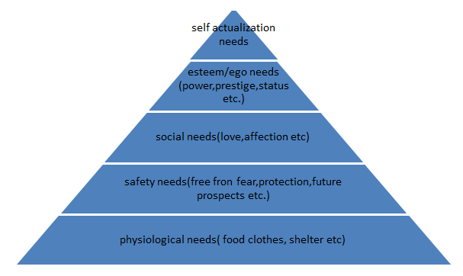
All human behavior is directed towards fulfilling their needs. Abhram Maslow’s needs hierarchy theory is based upon the needs of human beings. According to this theory, each and every people have certain needs. In response to that need, s/he is motivated to do work. Human needs have hierarchy. That’s why to motivate any people to work. The need of that person should be fulfilled according to hierarchy because as one need of that person is satisfied, another need will be created respectively. The needs have been classified in a hierarchy as follows:
· Physiological needs: These needs are fundamental or basic need of human being such as food, water, clothes, shelter etc. Without these needs human being cannot survive. Therefore, these needs are necessary to operate the human life. In organization, the manager can provide the adequate lighting, comfortable temperatures and ventilation etc to motivate the employees at first. These are the lowest order needs and assume top priority
· Safety/ security needs: An individual wants to be free from the fear of losing job, food, shelter etc which is known as safety or security needs. It is second important need because after fulfilling physiological need people want the safety and security needs. These needs may be job security, old age provision, pension plans, insurance, security from risk etc
· Social needs: It is the third hierarchy of needs which comes after fulfilling safety or security needs. Man is social in nature. Therefore, human beings always want to live in society or group which loves him/her the most. These needs include love, affection, friendship, social acceptance etc. So a manager can initiate participation of the employees as part of association to motivate the people.
· Esteem/ego needs: After fulfilling the social needs of people, they now want esteem needs by which they can have some special and unique place or status for him/her. They want to be prestigious and respected which is known as esteem or ego need. It is the second last need of Maslow’s need hierarchy theory. This need includes self-confident, self-respect, prestige, power, status, job title etc. So s/he wants to be strong and want to have immense power from which s/he can get self-satisfaction. A manager can provide the attractive job position to employees to fulfill esteem or ego needs.
· Self-actualization needs: Maslow said that self-actualization is the last and highest need in his hierarchy. After all needs are fulfilled especially including esteem/ego needs they now want or desire to help others. It is maximization of one’s potential. In this need people want to be satisfied in their desire? It includes challenging jobs, creativity, risk bearing capacity etc.

Herzberg's Motivation-Hygiene Theory
(Two Factor Theory)
To better understand employee attitudes and motivation, Frederick Herzberg performed studies to determine which factors in an employee's work environment caused satisfaction or dissatisfaction. He published his findings in the 1959 book The Motivation to Work.
The studies included interviews in which employees where asked what pleased and displeased them about their work. Herzberg found that the factors causing job satisfaction (and presumably motivation) were different from those causing job dissatisfaction. He developed the motivation-hygiene theory to explain these results. He called the satisfiers motivators and the dissatisfiers hygiene factors, using the term "hygiene" in the sense that they are considered maintenance factors that are necessary to avoid dissatisfaction but that by themselves do not provide satisfaction.
The following table presents the top six factors causing dissatisfaction and the top six factors causing satisfaction, listed in the order of higher to lower importance.

Factors Affecting Job Attitudes
Leading to Dissatisfaction | Leading to Satisfaction
- Company policy  - Supervision  - Relationship w/Boss  - Work conditions  - Salary  - Relationship w/Peers | - Achievement  - Recognition  - Work itself  - Responsibility  - Advancement  - Growth
Herzberg reasoned that because the factors causing satisfaction are different from those causing dissatisfaction, the two feelings cannot simply be treated as opposites of one another. The opposite of satisfaction is not dissatisfaction, but rather, nosatisfaction. Similarly, the opposite of dissatisfaction is no dissatisfaction.
While at first glance this distinction between the two opposites may sound like a play on words, Herzberg argued that there are two distinct human needs portrayed. First, there are physiological needs that can be fulfilled by money, for example, to purchase food and shelter. Second, there is the psychological need to achieve and grow, and this need is fulfilled by activities that cause one to grow.
From the above table of results, one observes that the factors that determine whether there is dissatisfaction or no dissatisfaction are not part of the work itself, but rather, are external factors. Herzberg often referred to these hygiene factors as "KITA" factors, where KITA is an acronym for Kick In The A..., the process of providing incentives or a threat of punishment to cause someone to do something. Herzberg argues that these provide only short-run success because the motivator factors that determine whether there is satisfaction or no satisfaction are intrinsic to the job itself, and do not result from carrot and stick incentives.

Douglas McGregor

Theory X and Theory Y
Douglas McGregor in his book, "The Human Side of Enterprise" published in 1960 has examined theories on behavior of individuals at work, and he has formulated two models which he calls Theory X and Theory Y.

Theory X Assumptions
The average human being has an inherent dislike of work and will avoid it if he can.
- Because of their dislike for work, most people must be controlled and threatened before they will work hard enough.
- The average human prefers to be directed, dislikes responsibility, is unambiguous, and desires security above everything.
- These assumptions lie behind most organizational principles today, and give rise both to "tough" management with punishments and tight controls, and "soft" management which aims at harmony at work.
- Both these are "wrong" because man needs more than financial rewards at work, he also needs some deeper higher order motivation - the opportunity to fulfill himself.
- Theory X managers do not give their staff this opportunity so that the employees behave in the expected fashion.

Theory Y Assumptions
- The expenditure of physical and mental effort in work is as natural as play or rest.
- Control and punishment are not the only ways to make people work, man will direct himself if he is committed to the aims of the organization.
- If a job is satisfying, then the result will be commitment to the organization.
- The average man learns, under proper conditions, not only to accept but to seek responsibility.
- Imagination, creativity, and ingenuity can be used to solve work problems by a large number of employees.
- Under the conditions of modern industrial life, the intellectual potentialities of the average man are only partially utilized.

Techniques of motivation
1. Financial incentives: First techniques of motivation are financial incentives as money is indicator of success. Therefore it fulfills psychological safety and status need as people satisfy their needs by money. Wages, salary motivates employees to perform better.
2. Job enlargement: Under this technique, task assigned to do job are increased by adding simile task. So the scope of job enlargement is high for the motivation of subordinates. It is also known as horizontally leading of job.
3. Job enrichment: Under this technique jobs are made challenging and meaningful by increasing responsibility and growth opportunities. In such technique of motivation, planning and control responsibility are added to the job usually with less supervision and more self evaluation. It is also called vertical leading.
4. Job rotation: it refers to shifting an employee from one job to another. Such job rotation doesn’t mean hanging of their job but only the employees are rotated. By this it helps to develop the competency in several job which helps in development of employees.
5. Participation : Participation refers to involvement of employee in planning and decision making .it helps the employees feel that they are an asset of the organization which helps in developing ideas to solve the problems.
6. Delegation of authority:Delegation of authority is concerned with the granting of authority to the subordinates which helps in developing a feeling of dedication to work in an organization because it provides the employees high morale to perform any task.
7. Quality of work life:It is the relationship between employees’ and the total working environment of organization. It integrates employee needs and well being with improves productivity, higher job satisfaction and great employee involvement. It ensures higher level of satisfaction.
8. Management by objectives:It is used as a motivation and technique for self control of performance. By this technique superior and subordinates set goals and each individual subordinates responsibilities clearly defined which help to explore the sill and use in the organization effectively.
9. Behavior modification:The last technique of motivation is behavior modification. It develops positive motivation to the workers to do the work in desired behavior in order to modify behavior.

Unit 9
Communication

Meaning of communication
Communication is the process of transformation of information from one person to another. It is a process of exchanging opinions ideas, feelings, information, views and other fast between or among two or more people. It involves the systematic and continuous process of telling, listening and understanding. Communication skill means conveying the message to others and understanding the message from others. Business communication is a bridge of passing information between the management and the employees.
Process of communication
1. Source or sender: – the first step in the communication process is source or sender. The source is also called communicator. Communication begins when someone has some idea, information, view, feeling to transmit. The communicator may be a person, group or an organization. When the communicator intends to communicate to somebody communicator prepares the message
2. Encoding: – the idea or feeling the sender has to be translated into some language or symbols. This process is called encoding. The sender must choose appropriate words, symbols, pictures etc to express his/her idea.. While selecting the symbols, the sender has to pay attention about the receiver understanding the message.
3. Message or medium: – the medium is simply the pathway for transmission of the message. Some medium must be selected. This channel is chosen by the sender. They can be formal or informal. Examples are face to face , email, letters, fax. Telephone etc
4. Decoding to the receiver: – the receiver assigns some meaning to the symbol transmitted by the source, so the receiver interprets the message and the process is known as decoding. It is not an easy task because words have different meaning for different people. Problems of communication break down frequently.
5. Feedback: – this is the final phase. Feedback is the reaction of the receiver. The receiver has to confirm whether or not the message has been received or not. It is only taken in two-way communication.
6. Noise: – it is interference with the normal flow of information. It disturbs the communication system. No matter how well designed is the communication system; if noise exists the message received is different from message sent. Example: – noise of machines, vehicles, loud voice etc.
Barriers to effective communication
A. Physical barriers
Internal structure of the organization and layout of office machines and equipments creates physical barriers in communication
a. Distance: – communication is found obstructed in long distance. Like communication between America and Nepal.
b. Noise: – it is from external sources and affects the communication process. Noise negatively affects the accuracy
c. Physical arrangement: – the physical arrangement of organizational sources like men, money, material and machine obstruct the communication process.
B. Semantic barriers
The use of difficult and multiple use of languages, words, figures, symbols create semantic barriers.
a. Language: – we can find some words having different meaning. As meaning sent by the sender can be quite different from the meaning understood by the receiver. Long and complex sentences creates problem in communication process.
b. Jargons: – technical or unfamiliar language creates barriers to communication that may be drawn from the literature. So message should be simple and condensed as far as possible so that no confusion creation will be there to the receiver.
C. Organizational barriers
It is raised from the organizational goals, regulations, structure and culture.
a. Poor planning: – it refers to the designing, encoding, channel selection and conflicting signals in the organization.
b. Structure complexities:- difficult organizational structure barrier for free flow of information. Appropriate communication process must be used.
c. Status differences: – it creates barrier for communication. Superior provides information to the subordinate about plans and policies. Different information is provided by different subordinates who create barrier in communication.
d. Organizational distance:- distance between sender and receiver also creates barriers to effective communication.
e. Information overload: – if superior provides too much information to the subordinate in short period receiver suffers from information overload which creates barriers to effective communication.
f. Timing: – communication can be obstructed if not done on time. If the information is not provided in time it creates barriers to effective communication.
D. Psychological barriers
It is the barriers to effective communication created from the lack of interest of the people from whom the communication is meant. People do not pay attention to the communication which are not interesting to them and which do not fulfill their want.
a. Perception: – it is the process of accepting and interpreting the information by the receiver. People receive things differently for a various number of reasons.
b. Filtering: – communication some time filters the negative information to make it more favorable to the receiver. In this process, knowingly or unknowingly some valuable information may be disposed.
c. Distrust: – superior provides information or message to the subordinates to their own view, ideas and opinion which create obstruction in communication.
d. Emotions: – emotion also creates barriers to effective communication like anger, het, mistrust, jealousy etc.
e. Viewpoint: – it also creates barriers to effective communication. It the receiver doesn’t clear the message and ignore without hearing, the message may create obstructions.
f. Defensiveness: – if the receiver receives the message as threat and interprets that message in the same way, it creates barriers to effective communication.
Types of communication
Formal and informal communication
1. Horizontal communication: – it is the process of lateral flow of information in order to coordinate work activities at the same level of management hierarchy. It helps in coordination of task, share information and minimize the conflict. In other words, it is the flow of information between the activities and to solve the organization problems, this can be shown by following figure.
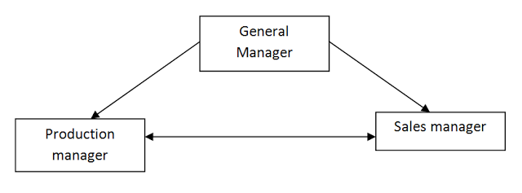
2. Vertical communication: – it is the process of upward and downward flow of information in order to coordinate work activities at the different level of management hierarchy. It helps in task directives, share information about rules and regulations, responsibility, problem, achievement and suggestions and minimize the conflict between subordinates and superior. There are two types of vertical communication
I. Downward communication: – it is the flow of information from top to bottom through formal lines of authority. Top level management transmits the information to subordinates about objectives, policies, strategies and responsibility.
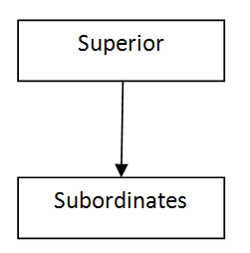
II. Upward communication: – it is the flow of information from bottom to top in an organization. Middle and low level management transmits the information to superior about problems, suggestions
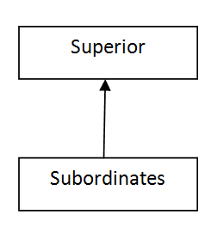
3. Diagonal communication: – it is the flow information between the superior and subordinates who are neither in the same department nor at the same level. It violates the principle of chain of command and unity of command.
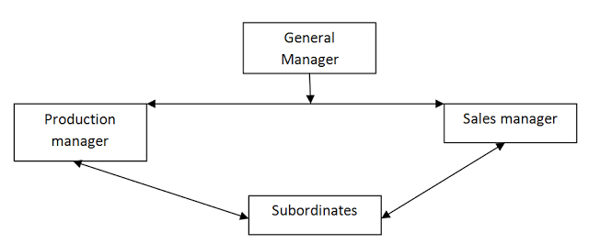

Channels of communication
- Formal communication channel
Networks are another aspect of direction and flow of communication. Bavelas has shown that communication patterns, or networks, influence groups in several important ways. Communication networks may affect the group's completion of the assigned task on time, the position of the de facto leader in the group, or they may affect the group members' satisfaction from occupying certain positions in the network. Although these findings are based on laboratory experiments, they have important implications for the dynamics of communication in formal organizations.
There are several patterns of formal communication:
- "Chain",
- "Wheel",
- "All-Channel" network,
- "Circle".
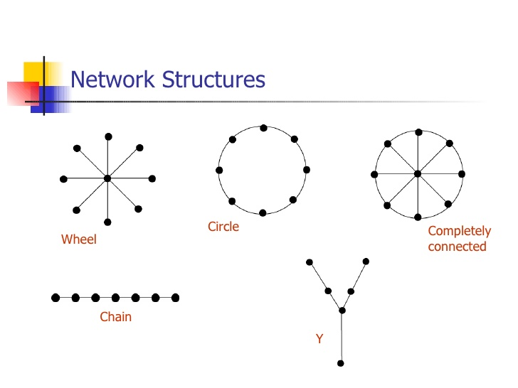

2. Informal Channel of Communication / Grapevine:
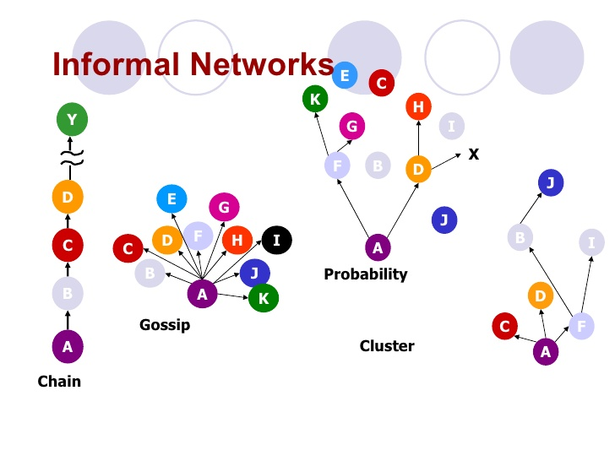
The informal channel of communication is often discouraged or looked down upon in an “organization, and is not officially sanctioned. It is popularly referred to as grapevine. This is because it runs in all directions irrespective of the formal structure.
The origin of the term grapevine can be traced to the way the botanical vine grew over telegraph wires, making telegraphic messages go in unintended directions. In business life, grapevine owes its existence to man’s gossipy nature.
Humans tend to speak loosely or lightly with their associates wherever they may be. Time to time they feel the need to get freed from the necessity to stick to logic or truth.
As people go about their work, they have casual conversation with their friends in the office. These conversations deal with both personal and business matters. This results in the generation of a rumour mill, which is a grapevine.
Grapevine is classified into four categories:
Single strand: Each one tells another.
Group or gossip chain: One tells all persons in his/her group.
Probability chain: Each randomly tells a number of people.
Cluster chain: Some tell selected others.
Grapevine satisfies the social needs of members, leads to more relaxed human relations (partly through the release of fantasy), serves to fill the possible gaps in the formal communication and links even those people who do not fall in the official chain of command.

Other characteristics of grapevine are:
(i) It is more people-oriented then issue-oriented.
(ii) May not be totally authentic and dependable.
(iii) Grapevine transmission flows in all directions in an organisation.
(iv) Grapevine information travels very fast.
(v) Its responsibility cannot be fixed.

Factors leading to grapevine:
A rumour mill becomes active when the following factors exist in an organisation:
(i) A lack of sense of direction, especially in times of crisis. The more the uncertainty, the greater the rumormongering.
(ii) The formation of favored groups of employees by the management. This breeds insecurity among other employees leading to rumors.
(iii) A lack of self-confidence amongst employees leads to the formation of groups. These groups often run rum our mills.

Advantages:
(i) Speed:
Speed is the most remarkable characteristic of this channel of communication. It is possible to transmit information remarkably fast since there are no formal barriers and no stopping. A rumour, thus, may spread like a wildfire.
(ii) Feedback:
The feedback through this channel is much faster than a formal channel of communication. The channel is like the pulse of an organisation. The reaction to the decisions, policies, directives and directions often reach managers faster through this channel than through the formal one.
(iii) Parallel function:
The informal channel does not have official sanction, but is an inevitable parallel to the formal channel. It works as a supplementary channel of communication in an organisation. Good managers have been known to use the informal channel to their benefit for transmitting information otherwise unfit for formal channels.
(iv) Support system:
A grapevine is an informal support system developed by employees within an organisation. It brings them closer and gives them immense satisfaction.

Disadvantages:
(i) Less credible:
A grapevine is less credible than a formal channel of communication. It cannot be taken seriously as it involves only the word of mouth. It is, therefore, likely to be contradicted.
(ii) Selective information:
Informal channels usually fail to carry the complete information. As a result, the receiver does not get the essence of the whole message. Mischief mongers or vested interests may use the channel for transmitting selective information.
(iii) Creates trouble:
A grapevine can foster trouble within an organisation as there is no control over the information sent, received, its portrayal and perceptions. Information gets distorted. A grapevine can be synonymous with the spreading of false or wild stories.
(iv) Leakage:
Information may get leaked at the wrong time. The term ‘open secret’ in an organisation can often is attributed to such leaks.

Effective use of informal channels of communication:
(i) The higher authorities should ensure that employees are well informed of the working of the organisation. This will reduce the tendency for distortion.
(ii) Activities that update knowledge should be frequent. This will prevent the generation of rumours.
(iii) The higher authorities should not indulge in favouritism.
(iv) A manager should conduct regular meetings with the employees.
(v) The manager should make efforts to identify popular employees who can serve as leaders for other employees.
(vi) As far as possible, employees should be involved in the decision-making process.
(vii) Managers should not indulge in loose talk.
(viii) A manager should be a good listener,
(ix) A manager should try to get regular reviews about his style of work.
Interpersonal and non verbal communication
Interpersonal communication
This type of communication takes place between two or more persons which can be in oral or written form.
Oral communication:
Oral communication is the process of expressing information or ideas by word of mouth. Learn more about the types and benefits of oral communication, and find out how you can improve your own oral communication abilities.

Definition and Types
Great communication skills are your ticket to success in the academic and business world. But have you ever been overcome by fear or anxiety prior to going on a job interview or speaking in front of an audience? Knowing when to choose oral communication and polishing your speaking skills can help you at every stage of your career.
Oral communication is the process of verbally transmitting information and ideas from one individual or group to another. Oral communication can be either Formal or Informal. Examples of informal oral communication include:
- Face-to-face conversations
- Telephone conversations
- Discussions that take place at business meetings
More formal types of oral communication include:
- Presentations at business meetings
- Classroom lectures
- Commencement speech given at a graduation ceremony
With advances in technology, new forms of oral communication continue to develop. Video Phones and Video Conferences combine audio and video so that workers in distant locations can both see and speak with each other. Other modern forms of oral communication include Podcasts (audio clips that you can access on the Internet) and Voiceover Internet Protocol (VoIP), which allows callers to communicate over the Internet and avoid telephone charges.
There are two main types of communication: oral and written. Written communication involves any type of message that makes use of the written word. Written communication is the most important and the most effective of any mode of business communication.
Examples of written communications generally used with clients or other businesses include:
- Email
- Internet websites
- Letters
- Proposals
- Telegrams,
- Faxes
- Postcards
- Contracts
- Advertisements
- Brochures and
- News releases.

Nonverbal communication is a very powerful medium of communication that entails sending and receiving messages through any of the human sense channels, without using language. Messages may occur on a conscious or unconscious level and may be intentional or not, and are usually, though are not limited to visual manifestations. Some forms of nonverbal communication include gestures, body language, facial expressions, eye contact, and posture, in addition to body temperature, movement, time and personal space. It is said that nonverbal communication comprises approximately two-thirds of all communication among people and groups.

